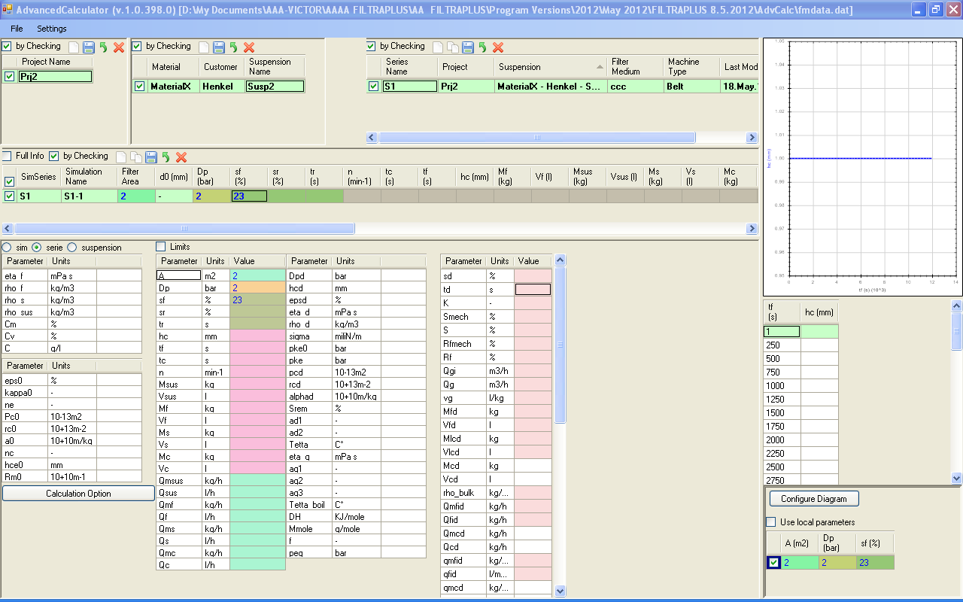
Why after entering sf I do not get sr? The sr I get it after I get I think tc. But we have sf=1-sr

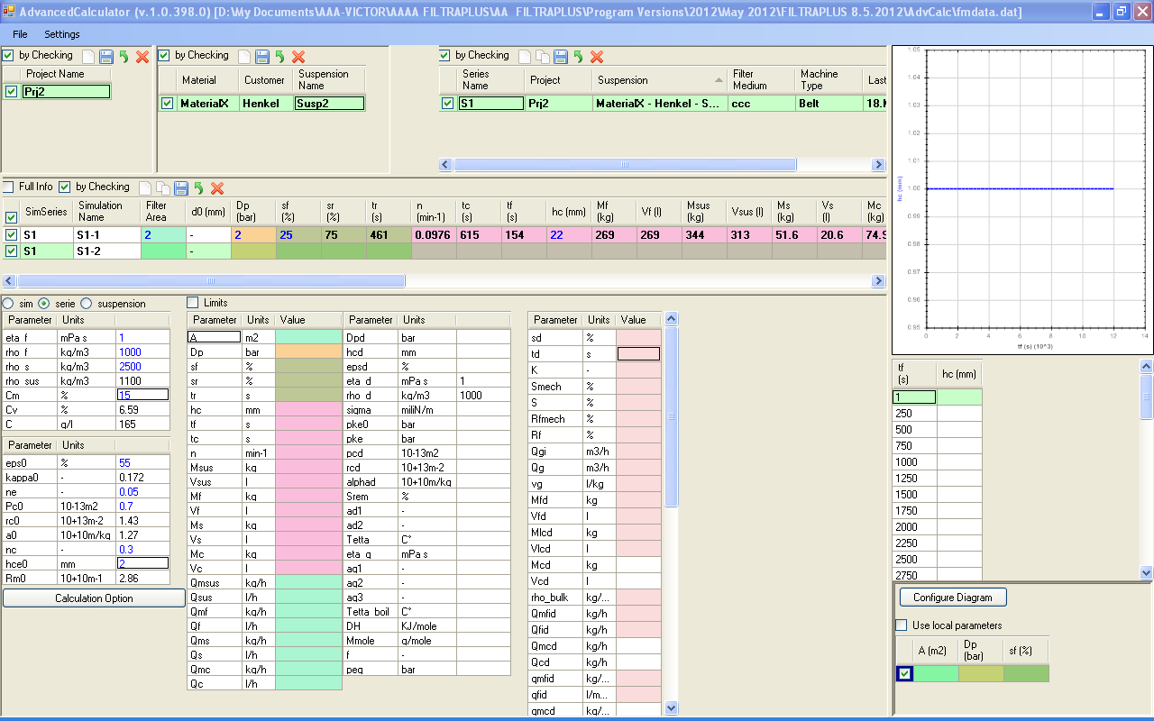
When creating a new simulation or duplicating then the new simulation should be always below the existing!

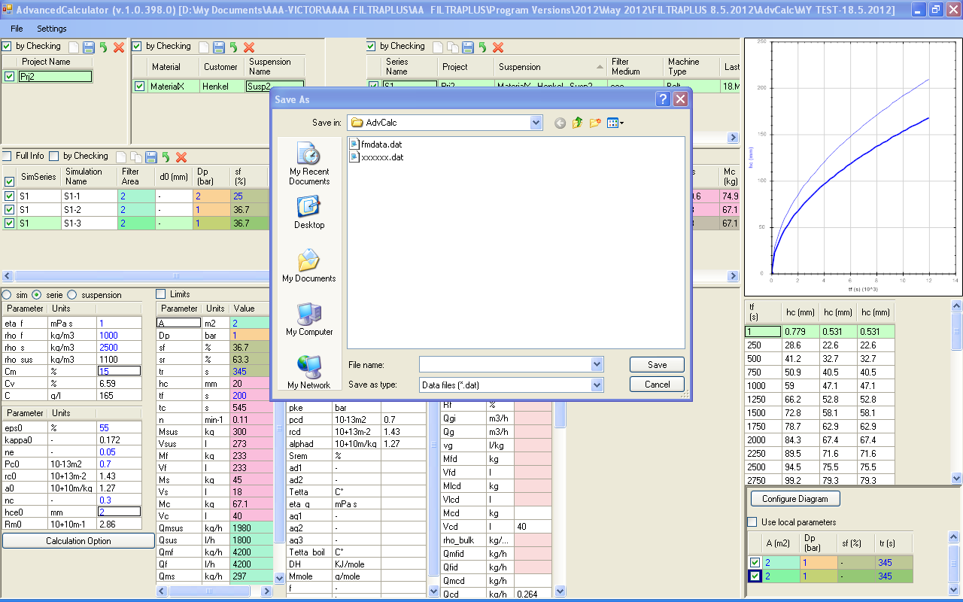I did saving before there with this name. Then I select from Menu “Save As” and I don’t see the saved file in the list.

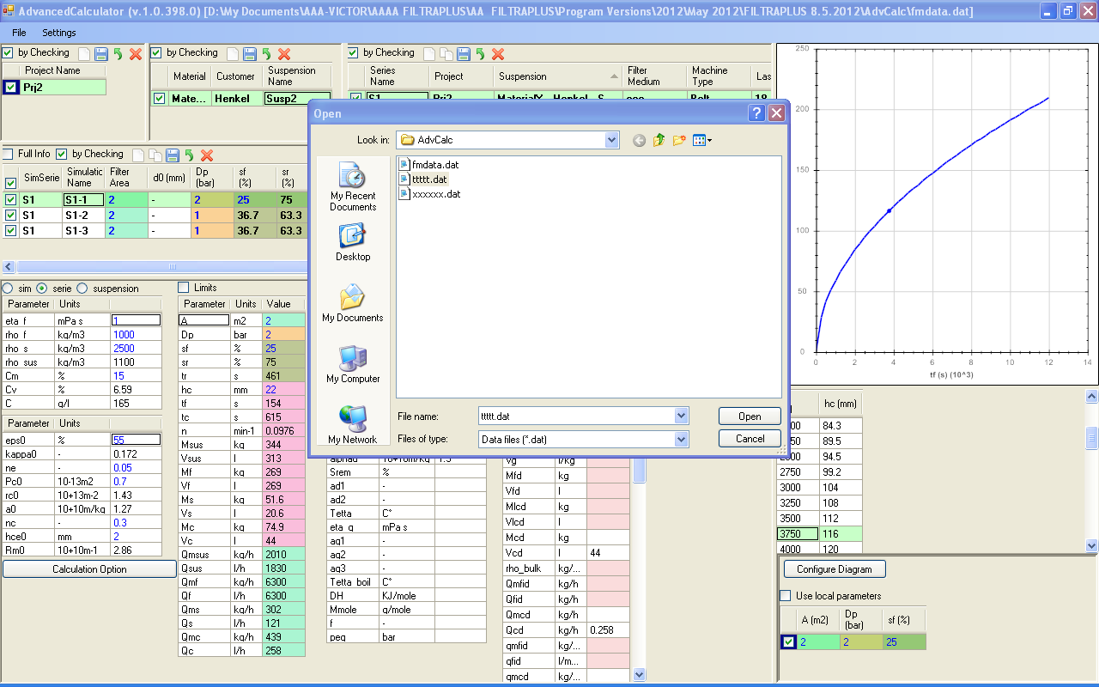
What I did: I wanted to exit the program and then it asks me if I want to exit without saving. Actually the question should be: “Save Changes?” and not “Exit without Saving?”. Then I said no, that means I want to save and I entered the file name “tttt”. Then the program exits and when I start again this tttt-file is there. But NOT the file I had originally created.

IT IS NECESSARY THAT WE LOAD AUTOMATICALLY THE LAST SAVED FILE AND NOT THE DEFAULT FILE.

Now I loaded the “tttt-file” and I wanted to exit immediately. The program doesn’t recognize that I did no changes and asks me if I want to exit without saving.

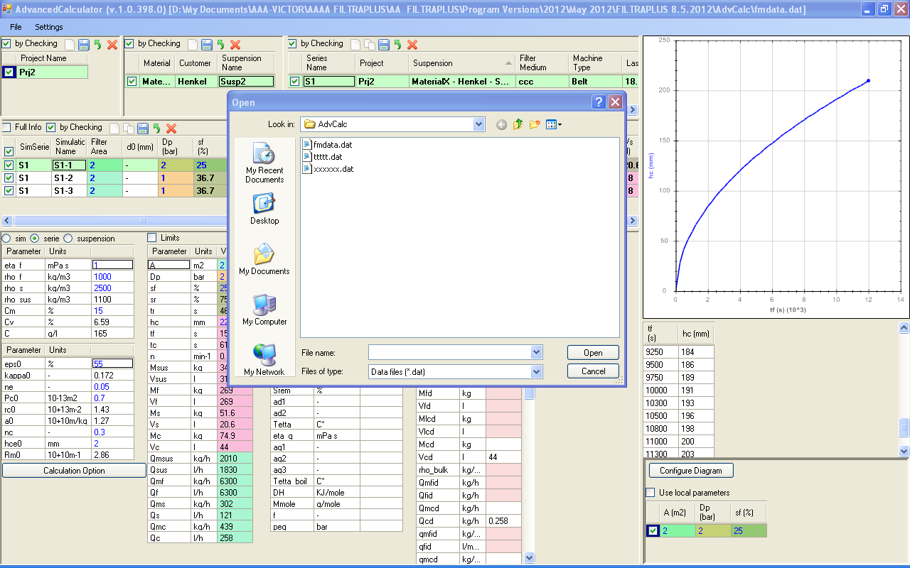
When we click “Open” or “Save as” then the program should display there in blue background color the current file.

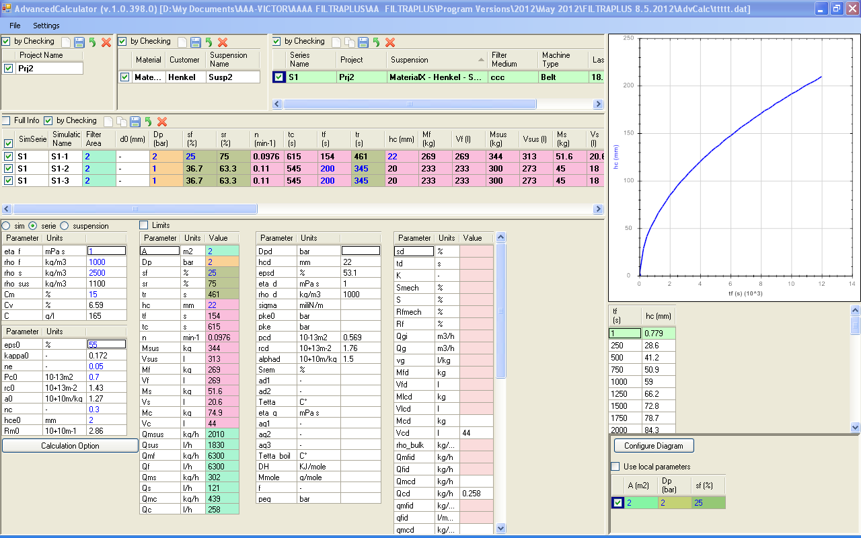
Now when we open a file then one simulation should be always selected. What we see above is not correct. No project, no suspension and no simulation is selected. Only the series.

IF FOR ONE SIMULATION WE HAVE THE DELIQUORING HIDDEN THEN THIS OPTION SHOULD BE SAVED IN THE FILE SO THAT WHEN WE EXIT THE SIMULATION OR EXIT THE PROGRAM COMING AGAIN TO THIS SIMULATION TO SEE ONLY CAKE FORMATION.

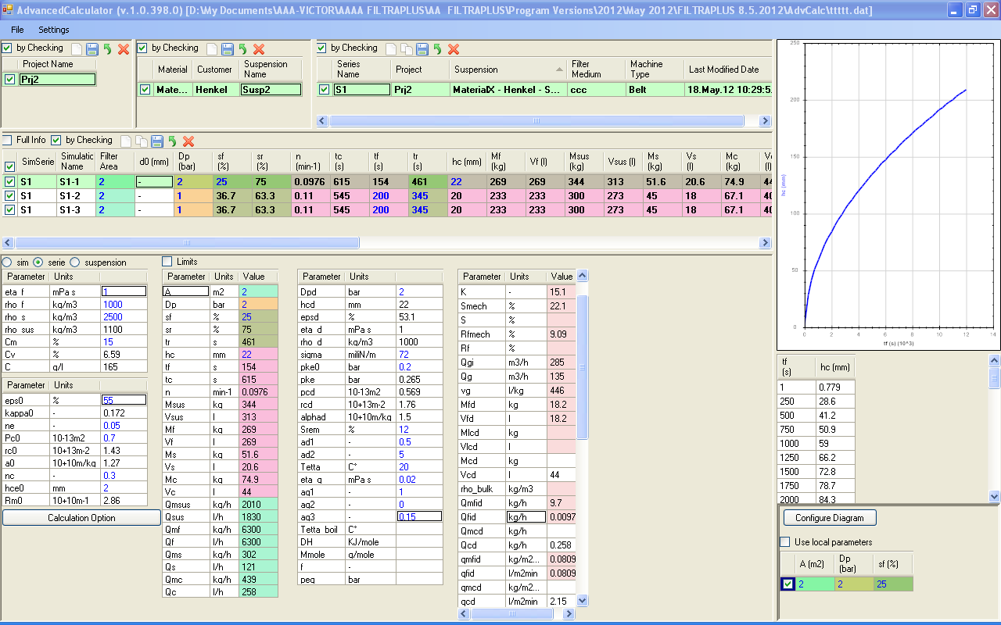
The unit of the parameter Qfid and Qcd is wrong (it should be m3/h and not kg/h)

The order of some parameters in deliquoring step should change. For example Mev has to be placed after Mfd, Vev after Vfd, so that we can compare.

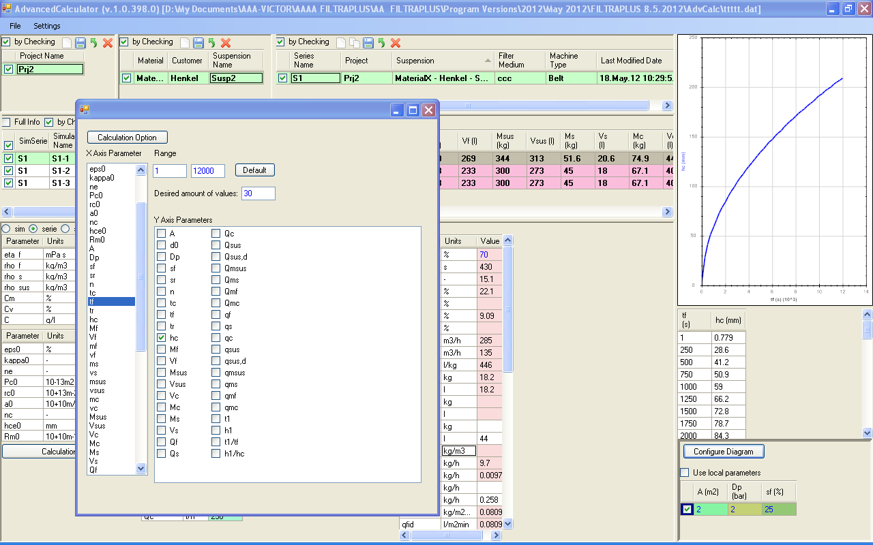
For the plots we should enable the deliquoring parameters also. In the x-axis list we should distinguish material parameters from setting parameters. Maybe better to have a list with 4 columns:

-material cake formation
-settings cake formation
--------------------------------
-material deliquoring
-settings deliquoring

Then for the y-axis parameters similar concept (in 4 columns we should separate according to the above concept. In the y-list we should have all parameters which can be calculated BUT display only those which are not hidden. If we have more than one simulations then we should display in the list one parameter if at least in one simulation this parameter is not hidden. Then for the plot we should have curves only for those simulations for which the selected parameter is not hidden!

